ORIEL Oriel Davies Gallery
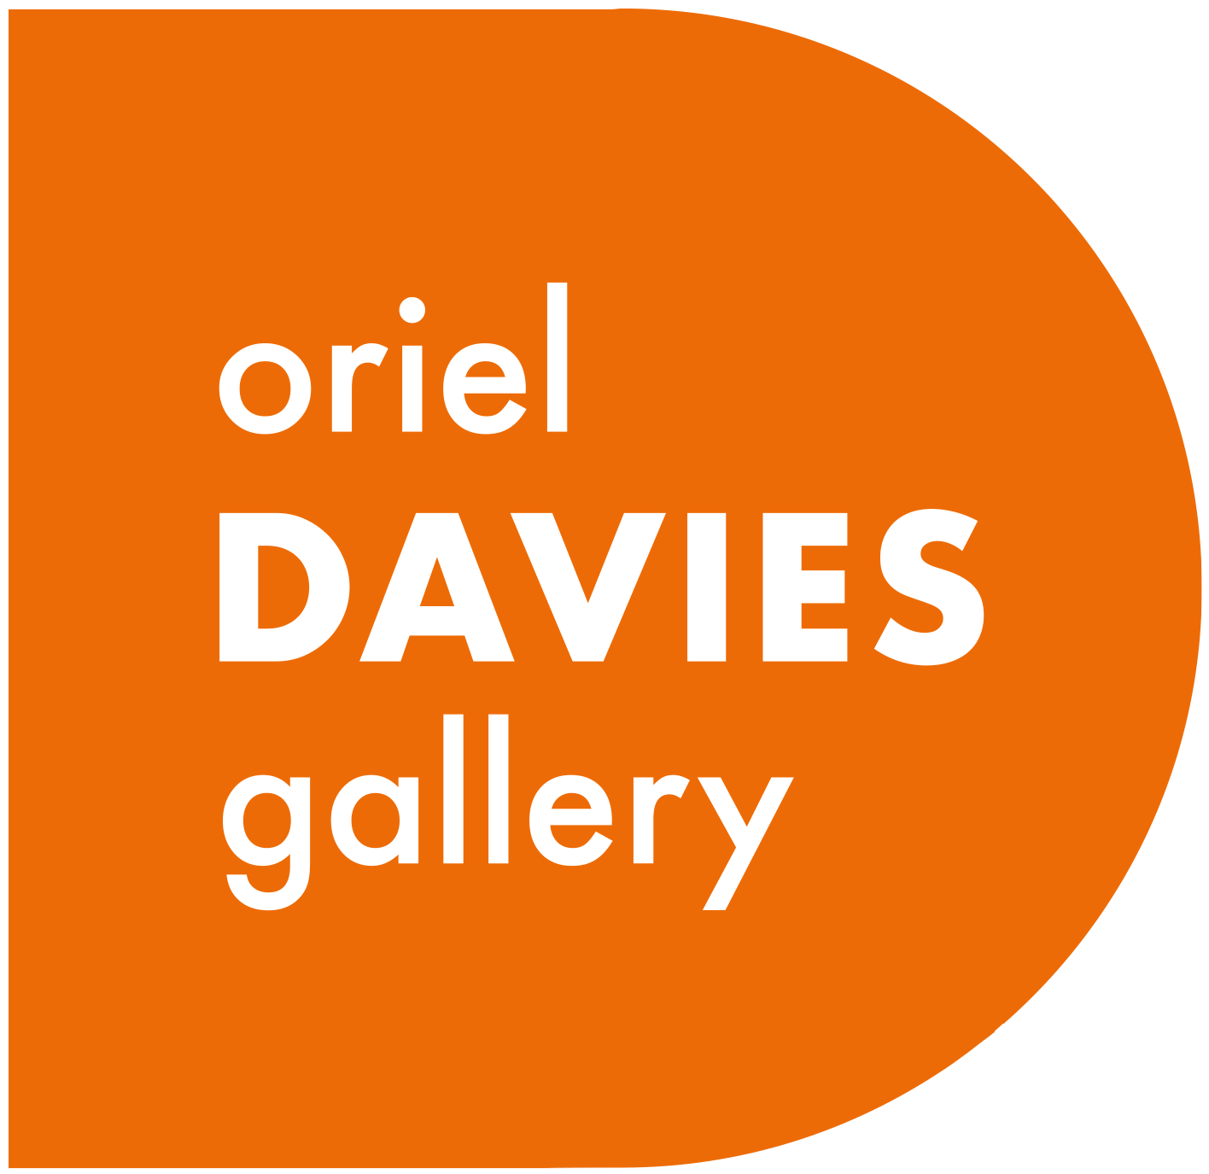
Expression of Interest Volunteering Form
Name
Address
Postcode
Mobile |  |  | Home No.
Email
Emergency Contact
Name
Relationship
Mobile No. Number
Home No.
Are you employed/ unemployed/ retired/ a student? Please provide any relevant information.

Why do you wish to volunteer with Oriel Davies Gallery?

What is your availability for Volunteering?

Do you have any relevant skills, knowledge or previous experience that you think might be useful for this role?

Do you require any assistance/access arrangements from us to support your volunteering?

References

Please give two references to whom confidential enquirers will be made . (References cannot be family members)
Name |  |  | Name
Address |  |  | Address
Postcode |  |  | Postcode
Email |  |  | Email
Privacy Notice
Your data will be processed by Oriel Davies Gallery only for the purposes of processing your expression of interest and helping you find suitable volunteer opportunities and ensuring your safety when volunteering with Oriel Davies Gallery. The processing of your personal data is necessary, with your consent, for the application to be completed before entering into a contract/agreement. Oriel Davies Gallery will not share your data with any other organisation.

Oriel Davies Gallery will retain your data for the duration of your volunteering placement and up to 6 years after the end of that placement. If you feel that Oriel Davies Gallery have mishandled your personal data at any time you can make a complaint to the Information Commissioners Office by visiting their website or by calling their helpline on 0303 123 1113. For further information about Oriel Davies gallery GDR Policy contact: desk@orieldavies.org

Declaration  I Agree that any information I provide may be used and shared within Oriel Davies Gallery for the above purposes.  I Consent to Oriel Davies Gallery undertaking checks as appropriate for the volunteering role applied for.  I certify that the information given within this application form is correct and that I have not omitted or misrepresented any details. |  |  |  |  | Tick to agree
Thank you for expressing an interest and completing this form.
Please email to Oriel Davies Gallery: desk@orieldavies.org or via post or in person to: Oriel Davies Gallery, The Park, Newtown, Powys SY16 2NZ

